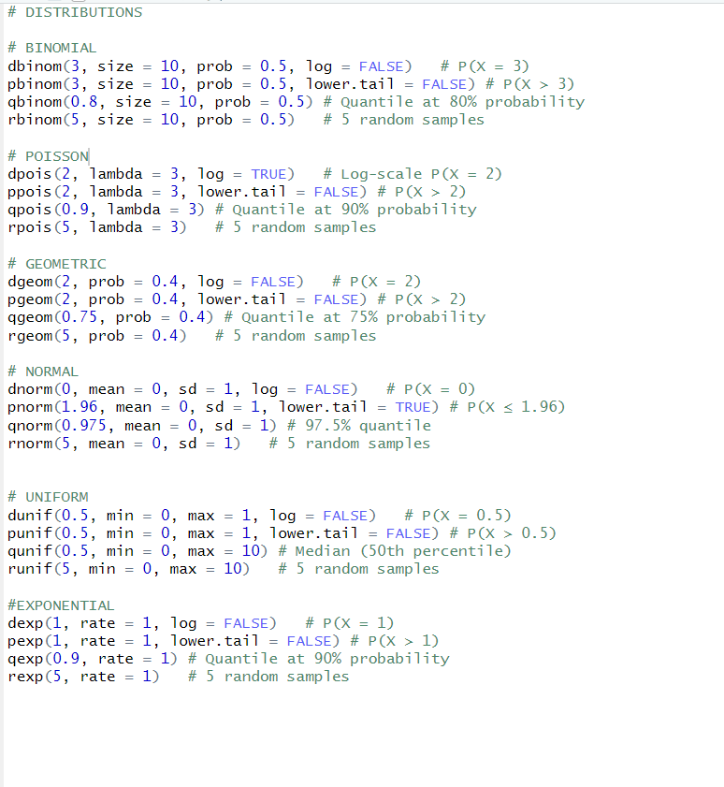
ATTRIBUTES
> x <- 1:5
> attr(x, "description") <- "Sample data"
> print(attributes(x))
$description
[1] "Sample data"

ARRAYS
> arr <- array(1:8, dim = c(2, 2, 2))
> print(arr)
, , 1

[,1] [,2]
[1,] 1 3
[2,] 2 4

, , 2

[,1] [,2]
[1,] 5 7
[2,] 6 8

> array(c('a','b'),dim=c(1,3,2))
, , 1

[,1] [,2] [,3]
[1,] "a" "b" "a"

, , 2

[,1] [,2] [,3]
[1,] "b" "a" "b"

DATA CLEANING (NA)
> data <- c(1, NA, 3)
> na.omit(data) # Output: 1 3
[1] 1 3
attr(,"na.action")
[1] 2
attr(,"class")
[1] "omit"
> na.exclude(data) # Output: 1 3
[1] 1 3
attr(,"na.action")
[1] 2
attr(,"class")
[1] "exclude"
> print(data)
[1] 1 NA 3
>
> data <- c(1, NA, 3, 4, 5, NA)
> clean_data <- na.omit(data)

BREAKS
> data <- c(1, 5, 10, 15)
> cut(data,breaks=3)
[1] (0.986,5.67] (0.986,5.67] (5.67,10.3] (10.3,15]
Levels: (0.986,5.67] (5.67,10.3] (10.3,15]
> print(cut(data, breaks = c(0, 5, 10, 15), labels = c("Low", "Medium", "High")))
[1] Low Low Medium High
Levels: Low Medium High
> data
[1] 1 5 10 15

T-TEST
>
> t.test(c(1,5,4,7,7,9),mu=20) # One-sample t-test

One Sample t-test

data: c(1, 5, 4, 7, 7, 9)
t = -12.637, df = 5, p-value = 5.514e-05
alternative hypothesis: true mean is not equal to 20
95 percent confidence interval:
2.550358 8.449642
sample estimates:
mean of x
5.5

> t.test(c(1,2,3),c(4,5,6),var.equal=TRUE) # Two-sample t-test

Two Sample t-test

data: c(1, 2, 3) and c(4, 5, 6)
t = -3.6742, df = 4, p-value = 0.02131
alternative hypothesis: true difference in means is not equal to 0
95 percent confidence interval:
-5.2669579 -0.7330421
sample estimates:
mean of x mean of y
2 5

> t.test(c(2,4,6,8),c(20,40,60,80),paired=TRUE) # Paired t-test

Paired t-test

data: c(2, 4, 6, 8) and c(20, 40, 60, 80)
t = -3.873, df = 3, p-value = 0.03047
alternative hypothesis: true mean difference is not equal to 0
95 percent confidence interval:
-81.976685 -8.023315
sample estimates:
mean difference
-45

ANOVA TEST

# ANOVA TEST DESIGN
# Analysis of Variance (ANOVA) is a statistical method used to compare the means of three or more groups
to determine if at least one group mean is significantly different from the others.
ANOVA can be performed using the aov() function.

> x=c(1,2,3,4,5)
> y=c(5,6,7,8,9)
> anova_result=aov(x~y,data=data)
> scores <- c(78, 85, 88, 92, 84, 89, 75, 81, 83)
> methods <- factor(c("A", "A", "A", "B", "B", "B", "C", "C", "C"))
> data <- data.frame(scores, methods)
> result <- aov(scores ~ methods, data = data)
> print(result)
Call:
aov(formula = scores ~ methods, data = data)

Terms:
methods Residuals
Sum of Squares 112.8889 120.0000
Deg. of Freedom 2 6

Residual standard error: 4.472136
Estimated effects may be unbalanced
> summary(result)
Df Sum Sq Mean Sq F value Pr(>F)
methods 2 112.9 56.44 2.822 0.137
Residuals 6 120.0 20.00
> teaching_method <- factor(c("A", "A", "A", "A", "B", "B", "B", "B"))
> study_hours <- factor(c("Low", "Low", "High", "High", "Low", "Low", "High", "High"))
> scores <- c(50, 55, 70, 75, 60, 65, 80, 85)
> data <- data.frame(teaching_method, study_hours, scores)
> result <- aov(scores ~ teaching_method * study_hours, data = data)
> print(result)
Call:
aov(formula = scores ~ teaching_method * study_hours, data = data)

Terms:
teaching_method study_hours teaching_method:study_hours Residuals
Sum of Squares 200 800 0 50
Deg. of Freedom 1 1 1 4

Residual standard error: 3.535534
Estimated effects may be unbalanced
> summary(result)
Df Sum Sq Mean Sq F value Pr(>F)
teaching_method 1 200 200.0 16 0.01613 *
study_hours 1 800 800.0 64 0.00132 **
teaching_method:study_hours 1 0 0.0 0 1.00000
Residuals 4 50 12.5
---
Signif. codes: 0 ‘***’ 0.001 ‘**’ 0.01 ‘*’ 0.05 ‘.’ 0.1 ‘ ’ 1

LINEAR REGRESSION

> set.seed(42)
# set.seed to set the random number generation seed.
> x=rnorm(100)
# x is a vector of 100 draws from a standard normal (mean=0, sd=1) distribution.
> e =rnorm(100,mean=0,sd=5)
# a little random noise called e from a normal distribution with mean=0 and sd= 5.
> y=5+15*x+e # y is then calculated as 5 + 15 * x + e.
> lm(y~x)

Call:
lm(formula = y ~ x)

Coefficients:
(Intercept) x
4.558 15.136

> df=data.frame(
+ x=c(1.371,-0.56,0.363,0.633,0.404,-1.06),
+ y=c(31.75,1.75,5.43,23.74,7.73,3.94)
+ )
> lm(y ~ x, data = df) # data is in columns in a data frame.

Call:
lm(formula = y ~ x, data = df)

Coefficients:
(Intercept) x
10.15 11.67

> m=lm(y~x,data=df)
> summary(m)

Call:
lm(formula = y ~ x, data = df)

Residuals:
1 2 3 4 5 6
5.604 -1.869 -8.957 6.203 -7.135 6.154

Coefficients:
Estimate Std. Error t value Pr(>|t|)
(Intercept) 10.152 3.269 3.105 0.0360 *
x 11.666 3.998 2.918 0.0433 *
---
Signif. codes: 0 ‘***’ 0.001 ‘**’ 0.01 ‘*’ 0.05 ‘.’ 0.1 ‘ ’ 1

Residual standard error: 7.784 on 4 degrees of freedom
Multiple R-squared: 0.6804, Adjusted R-squared: 0.6005
F-statistic: 8.516 on 1 and 4 DF, p-value: 0.04332

MULTIPLE REGRESSION
> set.seed(42)
> u <- rnorm(100)
> v <- rnorm(100, mean = 3, sd = 2)
> w <- rnorm(100, mean = -3, sd = 1)
> e <- rnorm(100, mean = 0, sd = 3)
> y = 5 + 4 * u + 3 * v + 2 * w + e
# create an equation using known coefficients to calculate our y variable.
> lm(y~u+v+w)

Call:
lm(formula = y ~ u + v + w)

Coefficients:
(Intercept) u v w
4.770 4.173 3.013 1.905

> df=data.frame(
+ y=c(31.75,1.75,5.43,23.74,7.73,3.94),
+ u=c(1.371,-0.565,0.363,0.633,0.404,-1.06),
+ v=c(5.02,5.09,0.994,6.697,1.666,3.211),
+ w=c(-5.00,-2.67,-1.83,-0.94,-4.38,-4.15)
+ )
> lm(y~u+v+w,data=df) # data is in columns in a data frame.

Call:
lm(formula = y ~ u + v + w, data = df)

Coefficients:
(Intercept) u v w
-4.800 10.389 2.778 -1.489

> m= lm(y~u+v+w,data=df)
> summary(m)

Call:
lm(formula = y ~ u + v + w, data = df)

Residuals:
1 2 3 4 5 6
0.9185 -5.6932 0.9732 1.9630 -2.8161 4.6547

Coefficients:
Estimate Std. Error t value Pr(>|t|)
(Intercept) -4.800 8.197 -0.586 0.6174
u 10.389 3.036 3.421 0.0758 .
v 2.778 1.236 2.248 0.1536
w -1.489 1.684 -0.884 0.4698
---
Signif. codes: 0 ‘***’ 0.001 ‘**’ 0.01 ‘*’ 0.05 ‘.’ 0.1 ‘ ’ 1

Residual standard error: 5.816 on 2 degrees of freedom
Multiple R-squared: 0.9108, Adjusted R-squared: 0.777
F-statistic: 6.807 on 3 and 2 DF, p-value: 0.1308

> coef(m) # Model coefficients
(Intercept) u v w
-4.800224 10.389153 2.777557 -1.488979
> confint(m) # Confidence intervals for model coefficients
2.5 % 97.5 %
(Intercept) -40.070599 30.470152
u -2.675796 23.454102
v -2.538372 8.093486
w -8.732539 5.754580
> resid(m) # Model residuals
1 2 3 4 5 6
0.9184625 -5.6932440 0.9732373 1.9629511 -2.8161336 4.6547266
> deviance(m) # Residual sum of squares
[1] 67.65406
> anova(m) # ANOVA table
Analysis of Variance Table

Response: y
Df Sum Sq Mean Sq F value Pr(>F)
u 1 516.23 516.23 15.2610 0.05972 .
v 1 148.05 148.05 4.3768 0.17153
w 1 26.46 26.46 0.7823 0.46976
Residuals 2 67.65 33.83
---
Signif. codes: 0 ‘***’ 0.001 ‘**’ 0.01 ‘*’ 0.05 ‘.’ 0.1 ‘ ’ 1

> # Data
> size <- c(1400, 1600, 1700, 1875, 1100) # Square footage
> price <- c(300000, 320000, 340000, 360000, 240000) # House prices
> # Fit linear model
> model <- lm(price ~ size)
> # Summary of the model
> summary(model)

Call:
lm(formula = price ~ size)

Residuals:
1 2 3 4 5
8717 -1975 2680 -4175 -5247

Coefficients:
Estimate Std. Error t value Pr(>|t|)
(Intercept) 76445.70 17357.70 4.404 0.021709 *
size 153.46 11.14 13.773 0.000828 ***
---
Signif. codes: 0 ‘***’ 0.001 ‘**’ 0.01 ‘*’ 0.05 ‘.’ 0.1 ‘ ’ 1

Residual standard error: 6634 on 3 degrees of freedom
Multiple R-squared: 0.9844, Adjusted R-squared: 0.9792
F-statistic: 189.7 on 1 and 3 DF, p-value: 0.0008283

SMOOTHENING
> # Data
> data <- c(10, 12, 15, 14, 13, 18, 20)
> # Apply moving average smoothing
> smooth_data <- filter(data, rep(1/3, 3), sides = 2)
> # Plot
> plot(data, type = "o", main = "Original vs Smoothed Data")
> lines(smooth_data, col = "red", type = "o")

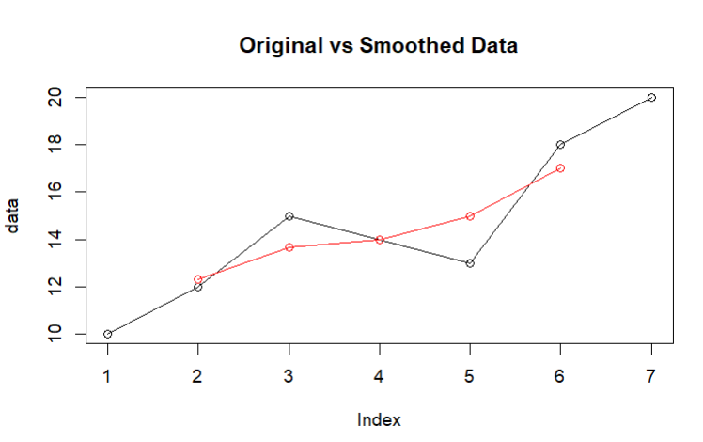

DATA CLEANING AND REPROCESSING
>
> data <- data.frame(Name = c("Alice", "Bob", NA), Age = c(25, NA, 30))
>
+ # REMOVING MISSING VALUES
+
+ # Remove rows with any missing values
+ data_cleaned <- na.omit(data)
> print(data_cleaned)

> # Remove rows with missing values only in the "Age" column
> data_cleaned_age <- data[!is.na(data$Age), ]
> print(data_cleaned_age)
Name Age
1 Alice 25
3 <NA> 30
> --------------
+ # FILLING MISSING VALUES
+
+ # Fill missing values in "Age" column with a default value (e.g., 0)
+ data_filled <- data
> data_filled$Age[is.na(data_filled$Age)] <- 0
> print(data_filled)

> # Fill missing values in "Age" column with the column's mean
> data_filled_mean <- data
> data_filled_mean$Age[is.na(data_filled_mean$Age)] <- mean(data$Age,na.rm = TRUE)
> print(data_filled_mean)
Name Age
1 Alice 25.0
2 Bob 27.5
3 <NA> 30.0
> ------------
+ # REMOVING DUPLICATES
+
+ # Create a data frame with duplicate rows
+ data <- data.frame(Name = c("Alice", "Bob", "Alice"), Age = c(25, 30,
+ 25))

> # Remove duplicate rows
> data_no_duplicates <- data[!duplicated(data), ]
> print(data_no_duplicates)
Name Age
1 Alice 25
2 Bob NA
3 <NA> 30

HANDLING OUTLINERS

+ # Create sample data with an outlier
+ data <- data.frame(Age = c(25, 30, 28, 100)) # 100 is an outlier

> # Remove outliers (values greater than 3 standard deviations from the mean)
> mean_age <- mean(data$Age)
> sd_age <- sd(data$Age)
> data_no_outliers <- data[data$Age < (mean_age + 3 * sd_age), ]
> print(data_no_outliers)
Name Age
NA <NA> NA
NA.1 <NA> NA
NA.2 <NA> NA
> # Replace outliers with NA
> data$Age[data$Age > (mean_age + 3 * sd_age)] <- NA
> print(data)
Name Age
1 Alice 25
2 Bob NA
3 <NA> 30
> --------------------------
+ # CONVERTING DATA TYPES
+
+ # Create a sample data frame with incorrect data types
+ data <- data.frame(Age = c("25", "30", "35"))

> # Convert "Age" column from character to numeric
> data$Age <- as.numeric(data$Age)
> print(data)
Name Age
1 Alice 25
2 Bob NA
3 <NA> 30
> ---------------------------
+ # RENAMING COLOUMNS
+
+ # Create a sample data frame with undescriptive column names
+ data <- data.frame(X1 = c(25, 30, 35), X2 = c("Alice", "Bob","Charlie"))

> # Rename columns
> colnames(data) <- c("Age", "Name")
> print(data)
Age Name
1 Alice 25
2 Bob NA
3 <NA> 30

SUMMARY()
+
+ # summarise(data,new_variable=aggregation_function(existing_variable))
+ data <-data.frame(numeric_variable = c(1, 9, 10, 16, 29, 30, 65, 74, 90, 94))

> result <-summarise(data, mean_value = mean(numeric_variable),sd_value = sd(numeric_variable))
> print(result)

> data <-data.frame(numeric_variable = c(1, 9, 10, 16, 29, 30, 65, 74, 90, 94),
+ another_variable=c(1, 9, 10, 16, 37, 30, 56, 78, 79, 99))
> result <-summarise(data,
+ mean_value = mean(numeric_variable),
+ mean_another = mean(another_variable))
> print(result)

> my_data <-data.frame(
+ location = c("Seattle", "Portland", "San Francisco", "Seattle", "Portland"),
+ temperature = c(53, 57, 62, 55, 58))
> result <-summarise( group_by(my_data, location), mean_temp = mean(temperature), count= n())
> print(result)

GRAPHS AND PLOTS

SCATTER PLOT

> x=c(2,4,6,8)
> y=c(3,6,9,12)
> plot(x,y,xlab='x-values',ylab='y-values',
+ col=rainbow(4),pch=11)

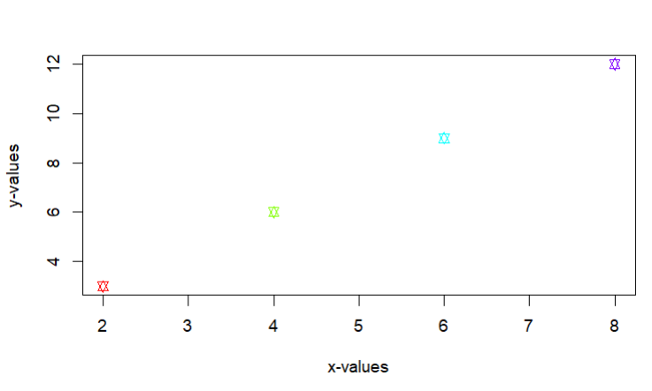
> install.packages('ggplot2')
> library(ggplot2)

> data=data.frame(Category=c('A','B','C','D','E'),
+ value1=c(10,30,45,25,50),
+ value2=c(15,20,45,30,14))
> ggplot(data, aes(x=value1, y=value2, color=Category)) +
+ geom_point(size=5)+
+ labs(title = "dataset",
+ x = "value1",
+ y = "value2",
+ color = "Category")
> theme_minimal()

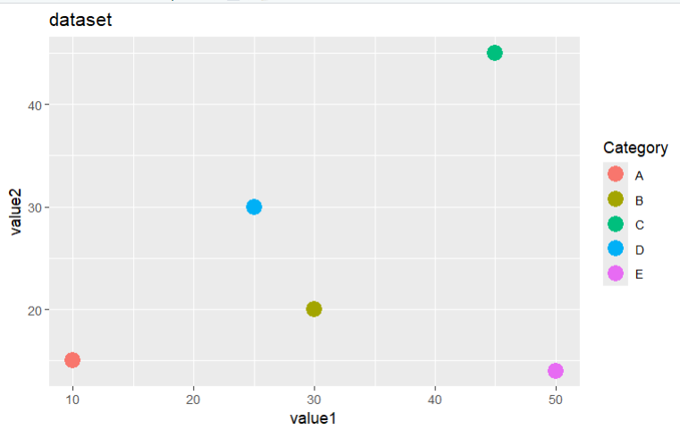

LINE GRAPHS
>
> # “o”: This value is used to draw both points and lines.
> v=c(3,12,6,18,15)
> plot(v,type='o')

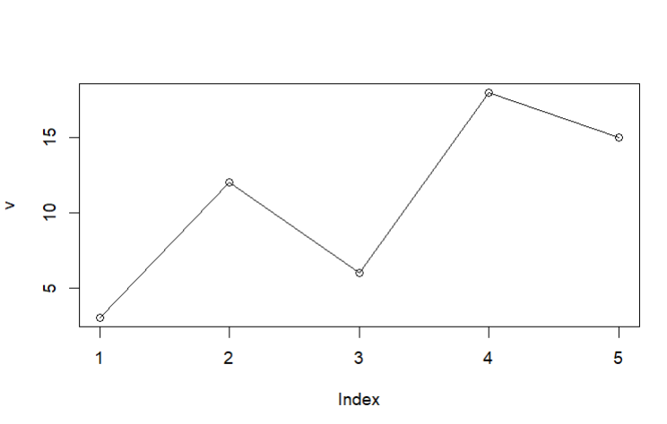
> v=c(10,5,25,30,15)
> plot(v,type='o',col='red',
+ xlab='x-value',ylab='y-value',
+ main='Line Graph')
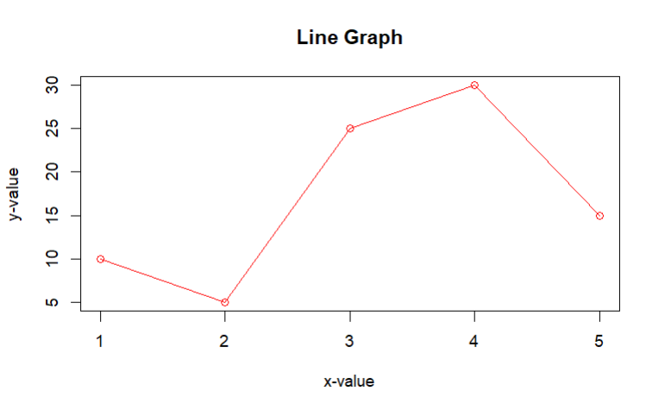
> # “l” : This value is used to draw only the lines.
> x=c(2,4,6,8)
> y=c(3,6,9,12)
> lines(x,y,type='b',col='green',lwd='0.5',lty='dashed')

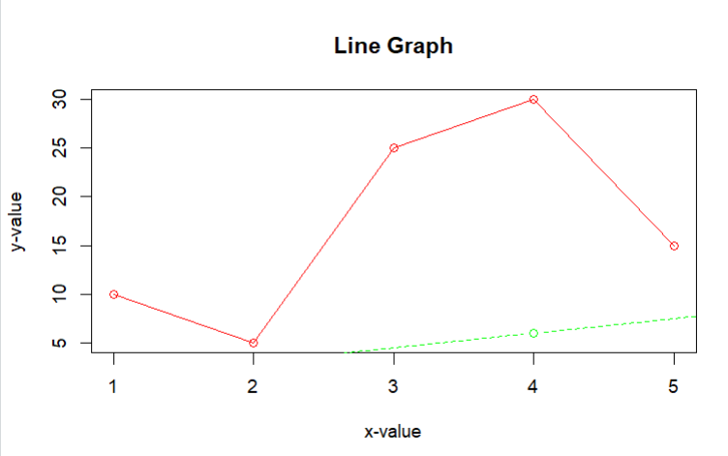

> # “p” : This value is used to draw only the points.
> v=c(10,5,25,30,15)
> plot(v,type='p',col='blue',
+ xlab='x-value',ylab='y-value',
+ main='Line Graph')

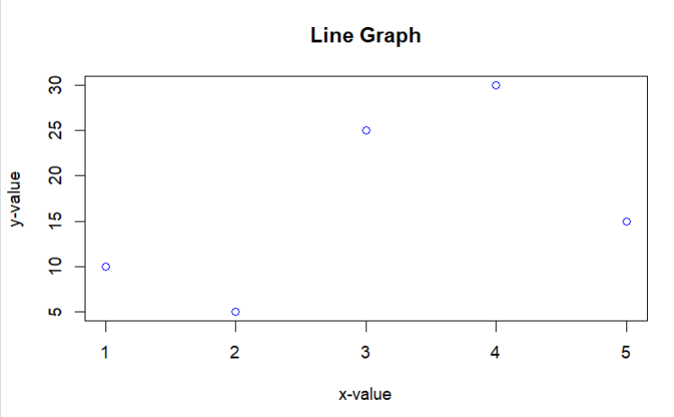
BAR PLOT
> x=c(2,4,6,8)
> y=c(3,6,9,12)
> barplot(x,y,xlab='x-value',ylab='y-value',
+ col='pink',border='red',
+ main='Bar Graph')
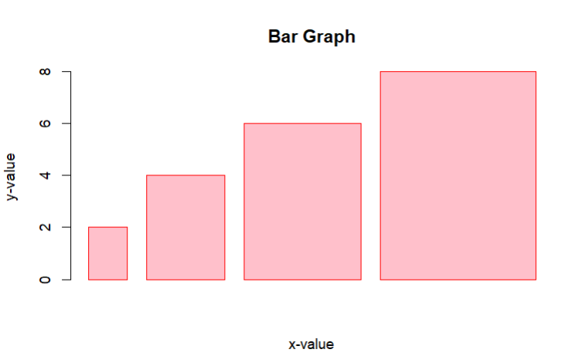

> png(file = "barplot.png")
> barplot(x,y,horizontal=TRUE,xlab='x-value',ylab='y-value',
+ col='lightblue',border='blue',
+ main='Bar Graph')
> dev.off()
RStudioGD
2
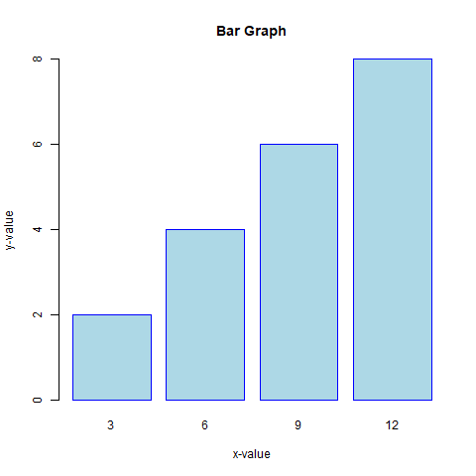
PIE CHART
> val=c(20,10,5,15,30)
> label=c('A','B','C','D','E')
> pie(val, labels = label, col = rainbow(length(val)),radius=0.8
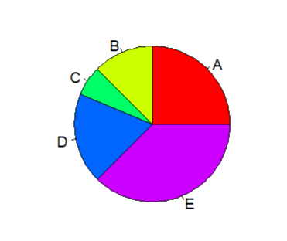
> # 3D Pie Chart
> install.packages("plotrix")
> library(plotrix)
> pie3D(val, labels = label, col = rainbow(length(val)),radius=0.8)
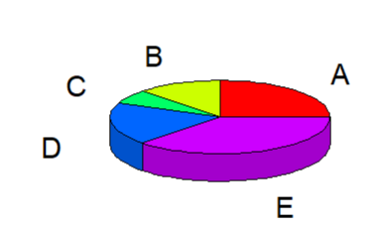
HISTOGRAM
> x=c(21, 23, 56, 90, 20, 7, 94, 12,
+ 57, 76, 69, 45, 34, 32, 49, 55, 57)
> hist(x,xlab='values',
+ col='yellow',border='orange',
+ col.lab='darkgreen',col.main='green')

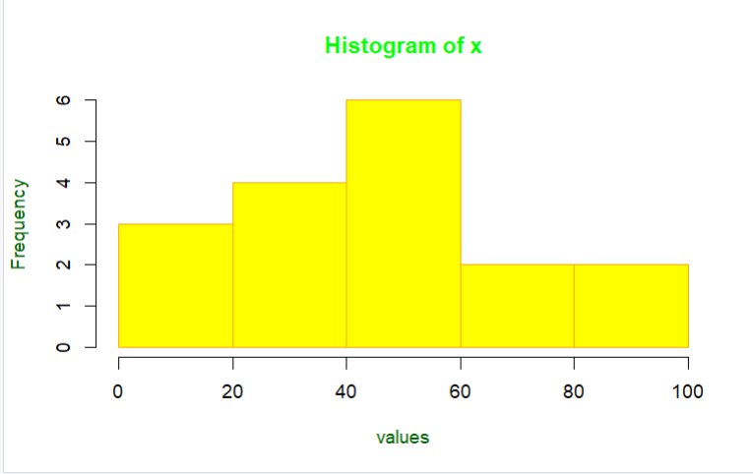
BOXPLOT
> x=c(2,4,6,8)
> y=c(3,6,9,12)
> boxplot(x~y,xlab='x-value',ylab='y-value',
+ col='pink',border='red',
+ main='Bar Graph')
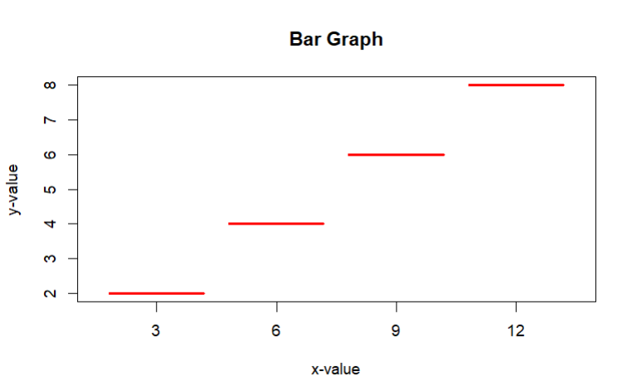
> # PLOT ARGUMENTS
> x=c(1,3,5,7)
> y=c(2,4,6,8)
> plot(x,y,type='b',col='magenta',main='Basic plot',
+ xlab='x-values',ylab='y-values',xlim=c(0,10),ylim=c(0,10))
> abline(h=5,col='red')
> text(3,4,'essential',col='cyan')
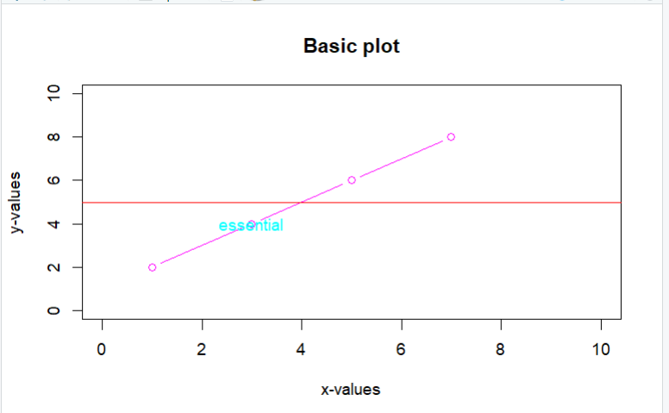
> # GGPLOT2
> # Install and load ggplot2
> install.packages("ggplot2")
> library(ggplot2)
> install.packages("ggplot2")
> # Data
> data <- data.frame(x = c(1, 2, 3, 4, 5), y = c(2, 4, 6, 8, 10))
>
> # Create a scatter plot
> ggplot(data, aes(x = x, y = y)) +
+ geom_point(color = "blue", size = 3) +
+ geom_line(color = "red") +
+ ggtitle("Scatter Plot with ggplot2") +
+ xlab("X-Axis") +
+ ylab("Y-Axis")
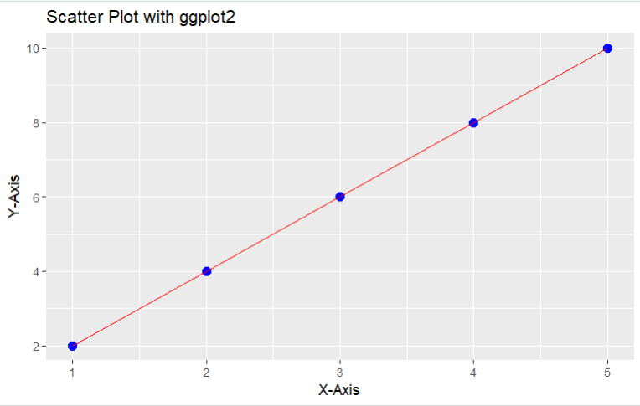

> # LABELS IN PLOTS
> x <- c(1, 2, 3, 4, 5)
> y <- c(2, 4, 6, 8, 10)
> # Base plot
> plot(x, y, main = "Adding Labels", xlab = "X-Axis", ylab = "Y-Axis", col = "blue", pch =10 )
> # Add text labels to points
> text(x, y, labels = paste("P", 1:5), pos = 3, col = "red")
